Dr. G.S. Chauhan  Dr. C. Lewis  Dr. P. Chawla | 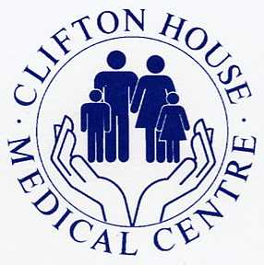 | 263-265 Beverley Road  Hull HU5 2ST  Telephone: 01482 341423

Dear patient

The GP practice have been notified that due to a national error in laboratory measurements, between 17th June and the end of October 2024, your diabetes test results (HbA1c) may not be accurate. We have worked with the laboratory to identify affected patients. Your record shows that you had a HbA1c blood test during this period, we would therefore like to invite you to arrange a follow-up appointment to have your HbA1c re-checked. If you have had your HbA1c repeated during January please disregard this letter. We will contact you in due course with the outcome of the results.

If you have any concerns, please contact the Patient Advice and Liaison Service on 01482 623065 / 01904 726262

Yours sincerely

The Practice Manager
Clifton House Medical Centre

